Report

Date | 24 September 2024
Team ID | PNT2022TMIDxxxxxx
Project Name | Employee Retention & Performance Analytics Report
Maximum Marks | 5 Marks

A report is a comprehensive document that provides a detailed and structured account of data analysis, findings, and insights. It is typically used for in-depth analysis, documentation, and communication of results. Reports are suitable for a diverse audience, including decision-makers, analysts, and stakeholders who need a comprehensive understanding of the data.
Designing a report in Power BI involves connecting to data sources, creating visualizations like charts and graphs, customizing their appearance and interactivity, organizing them logically on the canvas, formatting elements for consistency and clarity, and optionally creating dashboards for a summarized view. Throughout the process, it's essential to consider the audience's needs and ensure the report effectively communicates insights from the data. Finally, iterate based on feedback to continually improve the report's design and usefulness.
Observations drawn from reports in Power BI can provide valuable insights into business performance and trends.

Observations & Insights

Gender & Demographic Distribution
  - Observation: The organization possesses a highly mature workforce distribution profile, establishing an Average Age of 37.12 years balanced alongside an extensive baseline of

11.70 years of Average Work Experience.
  - Insight: While high-level gender parity and age spreads are fundamentally healthy across aggregate team structures, the localized tenure journey reveals explicit retention cliffs at distinct lifecycle stages. This proves that structural attrition tracks individual corporate milestones rather than standard general workforce demographics.

Workplace Model & Environmental Pressures
  - Observation: Cultural foundation indicators rank exceptionally high, supported by an Average Manager Support score of 6.61 coupled with a resilient Average Engagement score of 6.51.

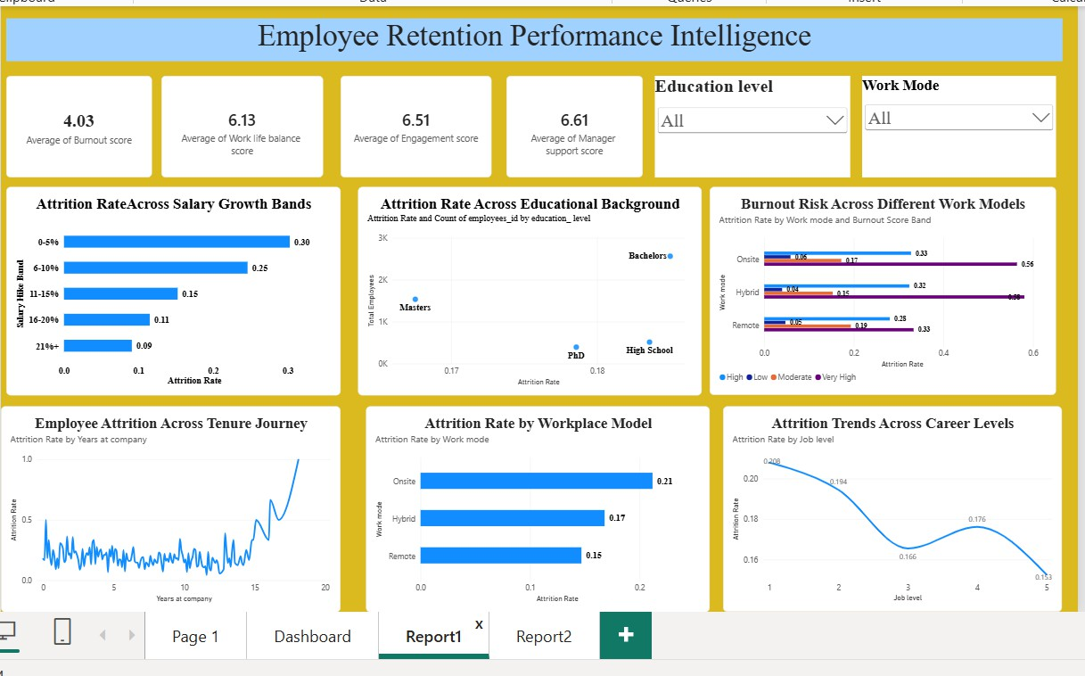
  - Insight: Despite optimized manager sentiment rankings, employee departures correlate tightly with operational formats (Remote vs. Hybrid vs. Onsite). Onsite infrastructure setups exhibit disproportionately higher exit spikes due to accelerated tracking on the Burnout Risk assessment (Average Burnout Score: 4.03), identifying structural workspace flexibility as a dominant preservation strategy.

Compensation & Promotion Disparities
  - Observation: Financial satisfaction tracking highlights a significant structural failure point clustered within localized compensation bounds, directly isolating extreme attrition behavior among personnel constrained to 0–5% and 6–10% salary growth bands.
  - Insight: Turnover levels fall precipitously once targeted salary adjustment rates scale beyond the 11% threshold, highlighting that minor inflation adjustments fail to anchor elite workforce talent. This economic attrition trend coordinates directly with the tenure cliff markers, showing that static wage stagnation acts as a primary trigger driving active career transitions.

Performance & Overtime Calibration
  - Observation: Core operational baseline output maintains distinctively productive levels across key departments, managing a stable Average Performance Rating of 3.62 out of 5 while demanding a consistent Average of 6.83 Weekly Overtime Hours.

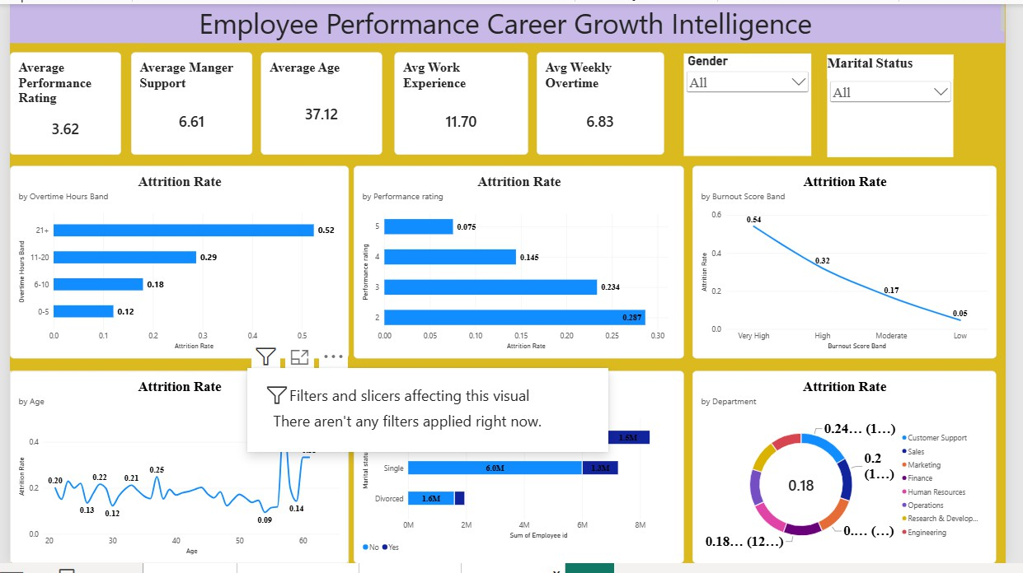
  - Insight: The underlying data isolates a profound corporate risk: highly rated, premium performance (Appraisal tiers 4 and 5) is systematically subsidized by excessive workload burdens. This dynamic heavily drives organizational strain up to a 4.03 Burnout rating, forcing a specialized 'success tax' trend where your most impactful talent exits prematurely due to persistent workplace exhaustion.

